

**Ain Shams University**

**Faculty of Computer and Information Science**

**Scientific Computing department**

**Ain shams university**

**Faculty of computer and information science**

**Bioinformatics department**

**Assignment 1 – Deep Learning & Neural Networks Course**

**Single Layer Perceptron**

**By**

|  |  |  |
| --- | --- | --- |
| **Name** | **ID** | **Section** |
| **Nour Mohamed Hussein Kamaly** | **20191700701** | **5** |
| **Nourhan Abdel-Karim Khalaf Abdel-Hafez** | **20191700716** | **5** |
| **Mohammed Nour-Elden Abbas Ismael** | **20191700583** | **4** |
| **Abdul-Rahman Sayed Ali Mohammed** | **20191700339** | **3** |

### Table of Contents

## List of Figures

## Features Linearity Visualization

1. Between the 3 classes

1. Between class Adelie (red) and Chinstrap (black)

The following combinations can discriminate between the 2 classes:

* Bill length & bill depth
* Bill length & gender

The following combinations can discriminate between the 2 classes but with some error as they are not linearly separable:

* Bill length & flipper length
* Bill length & body mass

The rest of the features cannot be separated linearly at all

1. Between class Adelie (red) and Gentoo (blue)

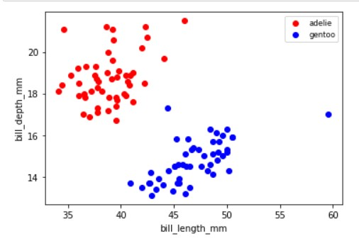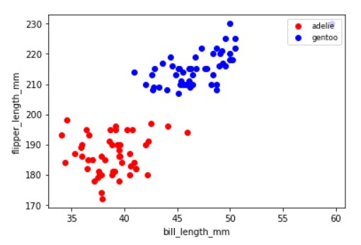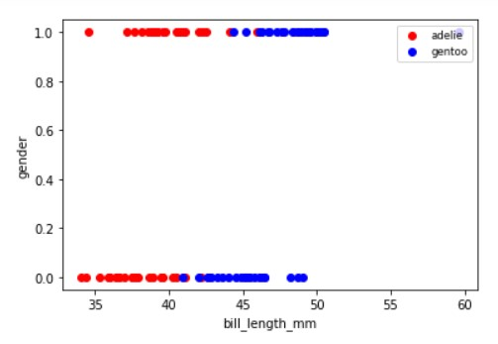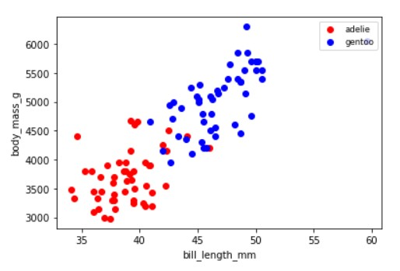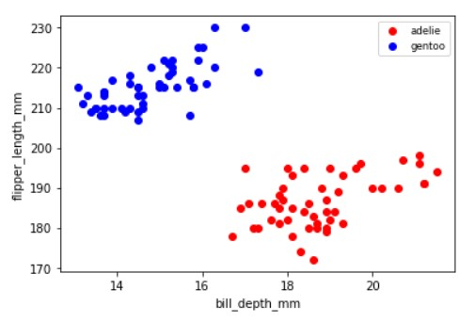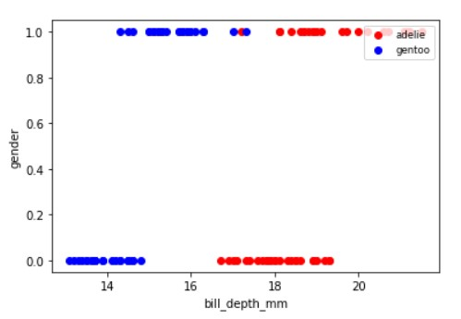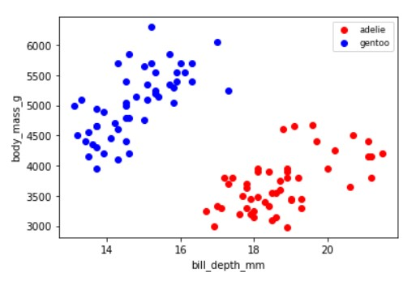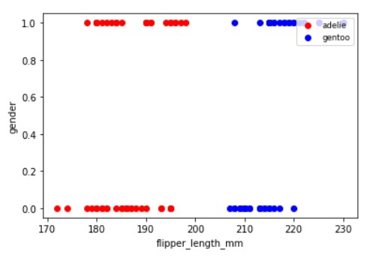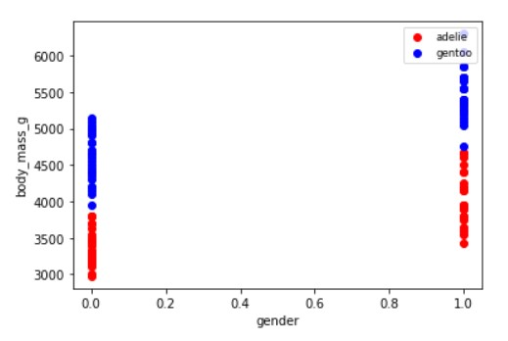

The following combinations can discriminate between the 2 classes as they are linearly separable:

* Bill length & bill depth
* Bill length & flipper length
* Bill depth & flipper length
* Bill depth & body mass
* Flipper length & gender
* Flipper length & body mass
* Gender & body mass

The following combinations can discriminate between the 2 classes but with some error as they are not linearly separable:

* Bill length & gender
* Bill depth & gender (error in 1 point)

1. Between class Chinstrap (blue) and Gentoo (black)

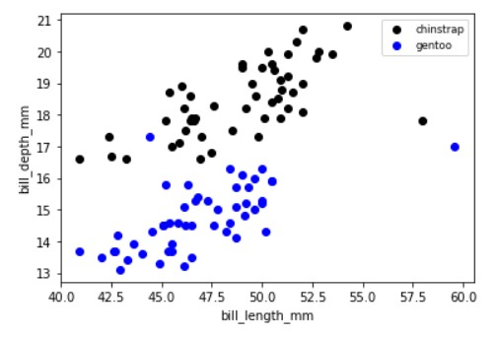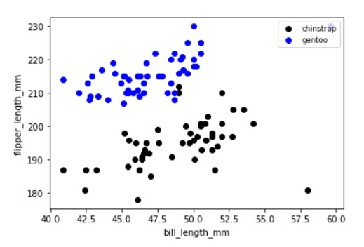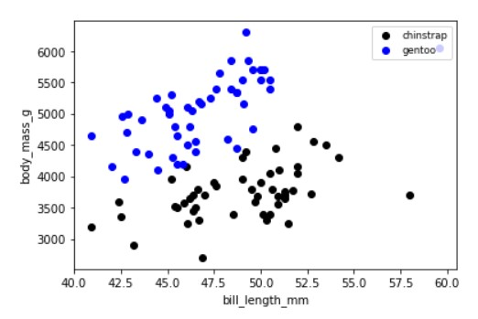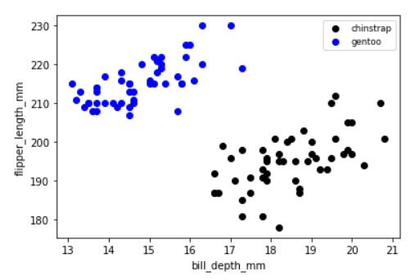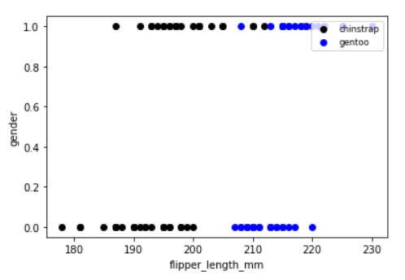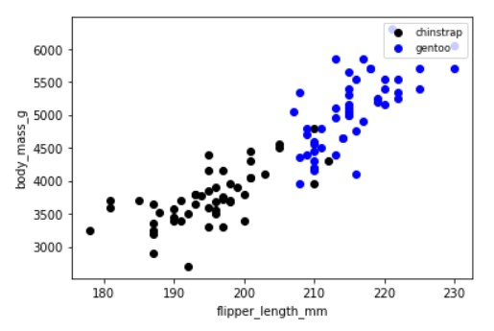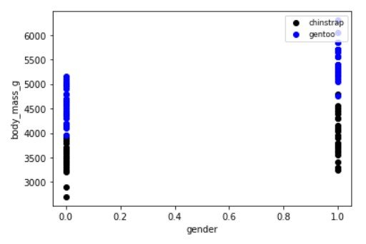

The following combinations can discriminate between the 2 classes:

* Bill depth & body mass
* Bill depth & flipper length
* Bill depth & gender

The following combinations can discriminate between the 2 classes but with some error as they are not linearly separable:

* Bill length & bill depth
* Bill length & flipper length
* Bill length & body mass
* Flipper length & body mass
* Flipper length & gender

Preprocessing

Training